**UMKC**

**Python Deep-Learning**

**From:**

**Rakesh Reddy Pallepati,**

**Class Id:37,**

**Lab Assignment1.**

**Introduction:**

Logistic Regression will predict probability of an outcome that will generate only two values called as dichotomy. A linear regression cannot be used for the prediction of binary variables for following reason:

A linear egression can predict the value greater than 1, As logistic Regression can have only two possible values that can be listed for the distribution of the model.

**Objective:**

* The objective here is to perform the logistic regression with a datasetof our choice.
* To display the Logistic Regression in the Tensor Board
* To Compare the accuracy by varying the hyper parameters

**Approach:**

Logistic Regression can be performed by several datasets such as Iris Dataset, Kaggle, Digits Dataset. Here, MNIST(Mixed National Institute of Standards and Technology database)dataset is used to achieve the Logistic Regression.

**Parameters:**

The Hyper parameters are as follows:

Learning Rate=0.1

No.Of Training Epochs used=40

Size of batch=100

Displaying step=1

**Workflow:**

The workflow for the logistic Regression Model is Explained below using the Tensor Board Graph in the Fig.

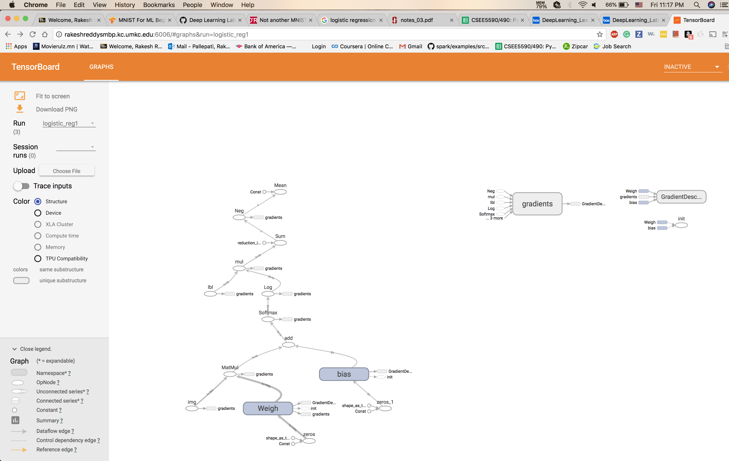

**Dataset:**

* Here MNISTdataset is used for various image-processing systems by training the images. As it is the Database of the handwritten digits.
* Each image is of the pixel size 28x28, and a 1D tensor of size 784.Each and every row indicate the different number in the below image.
* We will divide it into training Dataset, testing Dataset, Validation Dataset with the Tensorflow.

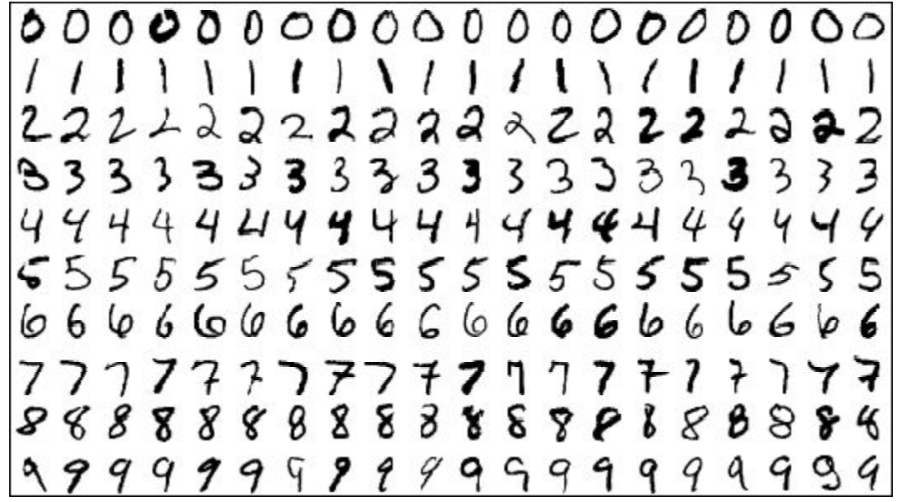

**from** tensorflow.examples.tutorials.mnist **import** input_data  
Dataset_mnist = input_data.read_data_sets(**"/tmp/data/"**, one_hot=**True**)  
print(Dataset_mnist)

**One hot encoding :**

It is used in the digital circuits, one-hot is used to represent the values multiple 0(Low)’s & Only 1(High) .

Here, In this dataset if we take the value as it will take as a vector of 10 elements and have high(1) at the index 2.

Ideally,Training Data of MNIST=55000, Testing Data=10000 & Validation Data=5000

Construction of Logistic Regression is much more equal to the linear Regression Model. Tensorflow is used for doing the batches at a time instead of doing it in each and every step.

To do as batches :

x_label = tf.place holder(tf.float32, [**None**, 784],name=**"img"**)

y_label= tf.place holder(tf.float32, [**None**, 10],name=**"lbl"**)

Here the data is feed into the placeholders instead of feeding single one.

batch_xs, batch_ys = mnist.train.next_batch(batch_size)

**Initialising the Hyper-Paramters :**

Learning Rate, Batch Size, Epochs, Display Step

lrn_rt = 0.01  
trin_ep = 25  
batch_siz = 100  
disp_step = 1

**Weights and Bias:**

Here, weights are initialized to the random variables with the mean value of 0 and the standard deviation will be of 0.01. The bias here will be initialized to zero.

Predicting the value form the input data by performing the matrix multiplication. Here it returns the Probability distribution label from the image provided using the softmax layer and the batchsize will be representing the 10 values.

Wt = tf.Var iable(tf.zeros([784, 10]),name=**"Weigh"**)  
bs = tf.Var iable(tf.zeros([10]),name=**"bias"**)

**Loss Function**:

To calculate the loss in the model, we need to use the Softmax Cross entropy and the logits function.

predict_val = tf.nn.softmax(tf.matmul(x_label, Wt) + bs,name=**"Softmax"**) cst_val = tf.reduce_ mean(-tf.reduce_sum(y_label*tf.log(predict_val), reduction_indices=1

**Training optimizer:**

The optimizer is used with learning rate of 0.01 to minimize the cost of the function.

optim_zer = tf.train.GradientDescentOptimizer(lrn_rt).minimize(cst_val)

**Session :**

We will start the session to perform the training and testing the Dataset. Here the Epochs are shown for the dataset and the accuracy is also shown in the output after perforing the training and testing the dataset.

**with** tf.Session() **as** sess:  
  
sess.run(initial)  
 writer = tf.summary.FileWriter(**'./graphs/logistic_reg1'**, sess.graph)  
  
**for** epch **in** range(trin_ep):  
 average_cst = 0.  
 total_batch = int(Dataset_mnist.train.num_examples/batch_siz)  
**for** i **in** range(total_batch):  
 batch_xs, batch_ys = Dataset_mnist.train.next_batch(batch_siz)  
_, c = sess.run([optim_zer, cst_val], feed _dict={x_label: batch_xs,  
 y_label: batch_ys})  
average_cst += c /total_batch  
 **if** (epch+1) % disp_step == 0:  
 print(**"Epochs:"**, **'%04d'** % (epch+1), **"cost="**, **"{:.9f}"**.format(average_cst))  
 writer.close()  
 print(**"Optimizing Finished Here!"**)  
  
crrect_prediction = tf.equal(tf.argmax(predict_val, 1), tf.argmax(y_label, 1))  
 acuracy = tf.reduce_mean(tf.cast(crrect_prediction, tf.float32))  
 print(**"Accuracy_of_the_model:"**, acuracy.eval({x_label: Dataset_mnist.test.images, y_label: Dataset_mnist.test.labels}))

**Configuration:**

This Lab Assignment is performed using the Pycharm Tool with Python Latest Version 3.6.4

**Evaluation & Discussion:**

In the above MNIST Dataset, The data is labeled using the Array format as below in the form of table and it is labeled as shown in the fig.

|  |  |  |  |  |  |  |  |  |  |  |
| --- | --- | --- | --- | --- | --- | --- | --- | --- | --- | --- |
| Label | 0 | 1 | 2 | 3 | 4 | 5 | 6 | 7 | 8 | 9 |
| Array | 0 | 0 | 0 | 0 | 0 | 0 | 0 | 1 | 0 | 0 |

If we display any random digit, for example in above case:

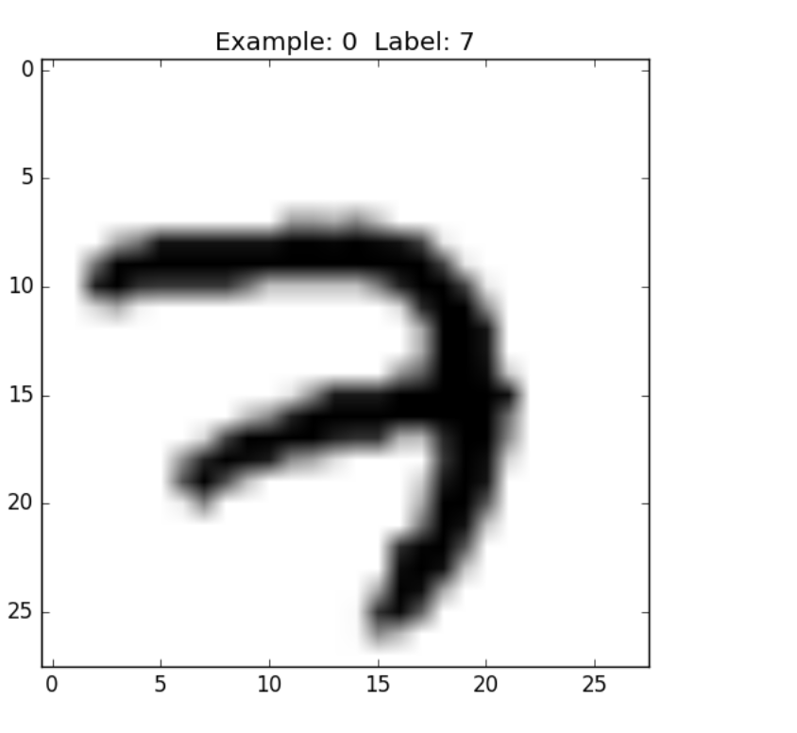

**Softmax Regression:**

The softmax Regression used here will be in the format of X*W+B by using the matmul function. If we visualize the function in the form of array as follows:

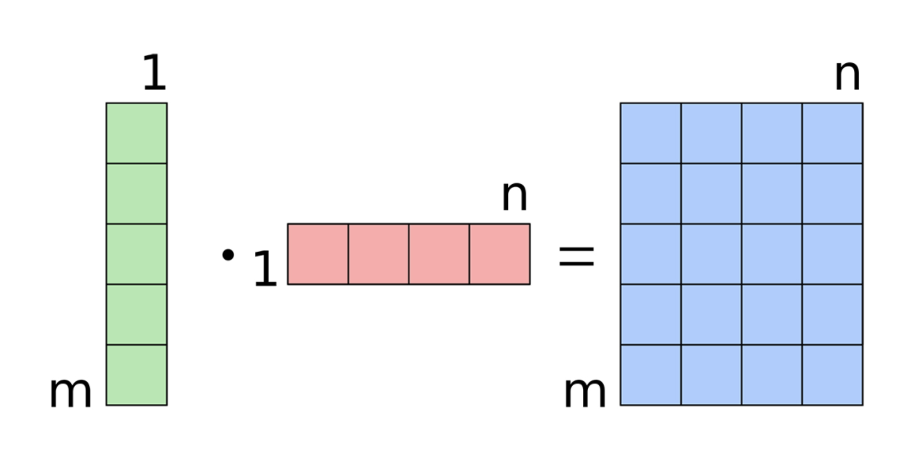

**Cross Entropy Function :**

This Function is to calculate the log of the products from ranging value 0 to1.

For Ex, If the value is approximately equal to zero then the result will be negative and if it closely or near to the value of 1 it will make as small Negative number

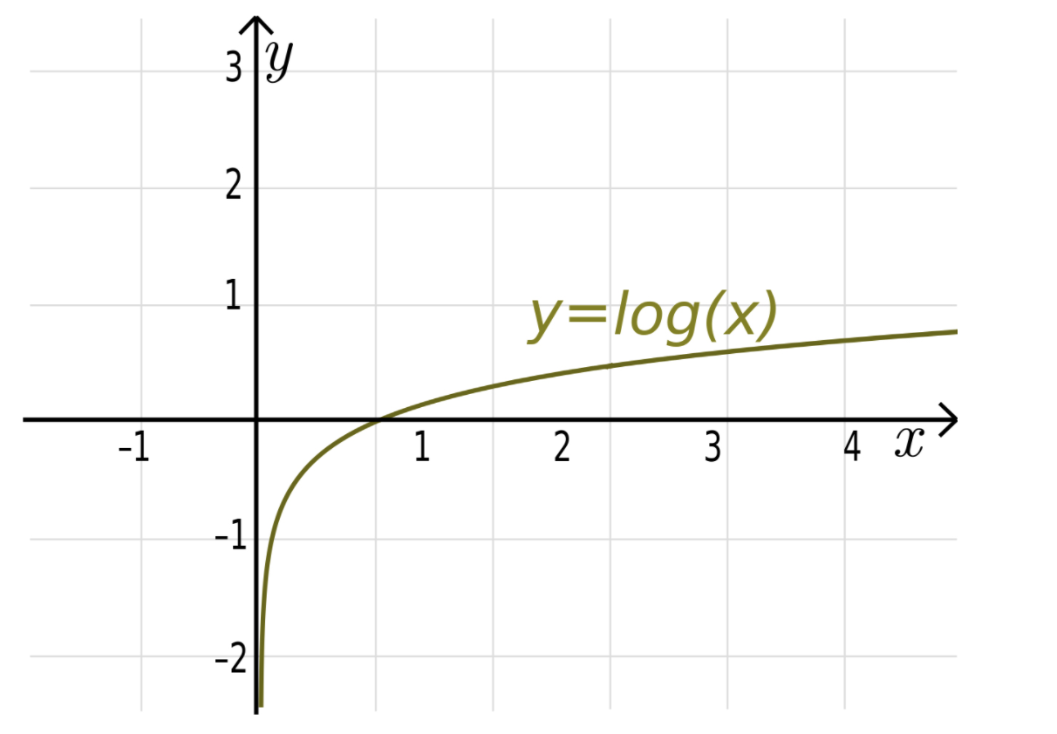

Here, If the prediction is wrong it will give the large number and small number if the prediction is correct

**Gradient Descent Optimizer:**

To get clear idea of the Gradient Descent Optimizer we need to imagine the loss of 784 Dimns based on the y_train and y_pred which have the values differing x,w&B. To explain it simply, Try to think Of y=x2 . The lowest point is obtained using the derivative of the cross entropy.

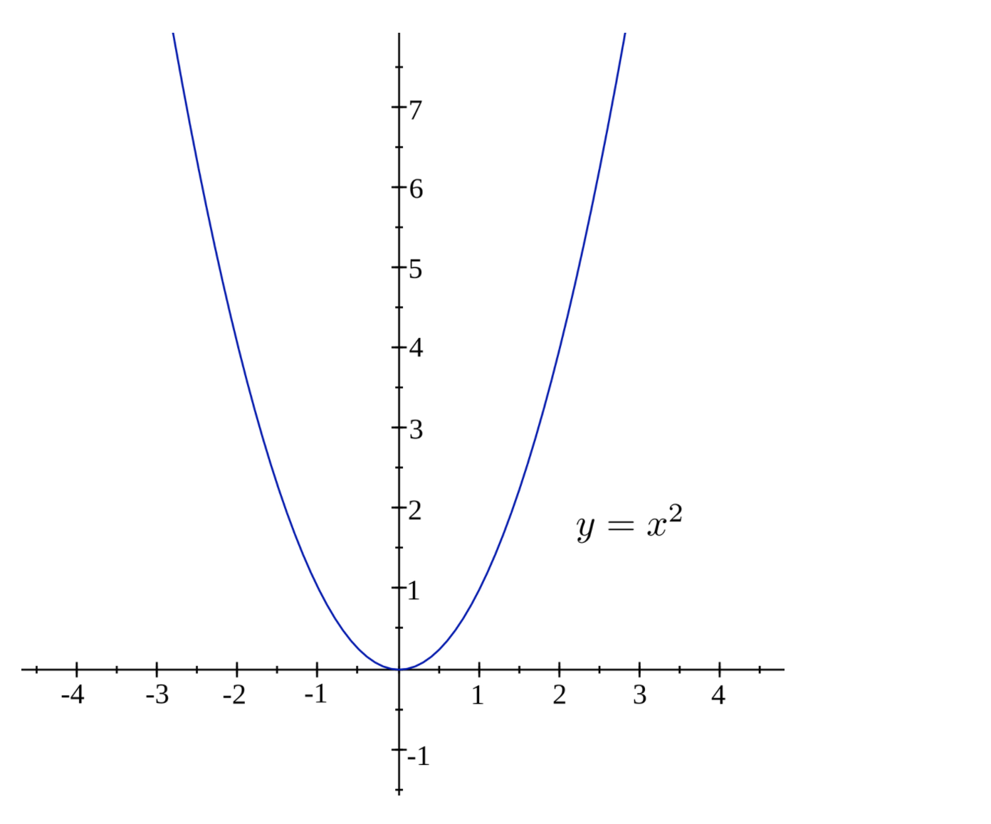

The basic workflow is as explained above by performing the softmax regression and the crossentrpy functionality is to decrease the mean-value Error and by using the Optimizer is to minimize the error as low as possible by gradually increasing the Accuracy of the Logistic Regression Model.

**Source Code:**

**from** __future__ **import** print_function  
  
**import** tensorflow **as** tf  
  
  
**from** tensorflow.examples.tutorials.mnist **import** input_data  
Dataset_mnist = input_data.read_data_sets(**"/tmp/data/"**, one_hot=**True**)  
print(Dataset_mnist)  
  
lrn_rt = 0.1  
trin_ep = 40  
batch_siz = 100  
disp_step = 1  
  
x_label = tf.place holder(tf.float32, [**None**, 784],name=**"img"**)

y_label= tf.place holder(tf.float32, [**None**, 10],name=**"lbl"**)

Wt = tf.Variable(tf.zeros([784, 10]),name=**"Weigh"**)  
bs = tf.Variable(tf.zeros([10]),name=**"bias"**)  
  
predict_val = tf.nn.softmax(tf.matmul(x_label, Wt) + bs,name=**"Softmax"**) *# Softmax*cst_val = tf.reduce_mean(-tf.reduce_sum(y_label*tf.log(predict_val), reduction_indices=1))

optim_zer = tf.train.GradientDescentOptimizer(lrn_rt).minimize(cst_val)

initial = tf.global_variables_initializer()  
**with** tf.Session() **as** sess:  
  
 sess.run(initial)  
 writer = tf.summary.FileWriter(**'./graphs/logistic_reg1'**, sess.graph)  
  
 **for** epch **in** range(trin_ep):  
 average_cst = 0.  
 total_batch = int(Dataset_mnist.train.num_examples/batch_siz)

**for** j **in** range(total_batch):  
 batch_xs, batch_ys = Dataset_mnist.train.next_batch(batch_siz)  
 *)* _, c = sess.run([optim_zer, cst_val], feed_dict={x_label: batch_xs,  
 y_label: batch_ys})  
 *# Compute average loss* average_cst += c / total_batch  
**if** (epch+1) % disp_step == 0:  
 print(**"Epochs:"**, **'%04d'** % (epch+1), **"cost="**, **"{:.9f}"**.format(average_cst))  
 writer.close()  
 print(**"Optimizing Finished Here!"**)  
  
crrect_prediction = tf.equal(tf.argmax(predict_val, 1), tf.argmax(y_label, 1))  
acuracy = tf.reduce_mean(tf.cast(crrect_prediction, tf.float32))  
 print(**"Accuracy_of_the_model:"**, acuracy.eval({x_label: Dataset_mnist.test.images, y_label: Dataset_mnist.test.labels}))

**Results:**

**Case 1:**

By changing the Hyperparameters, the Accuracy will be varied. We can see it in the below Code snippets

Training-Epochs=140

Batch-Size=10000

Display-Size=1

Learning-Rate=2

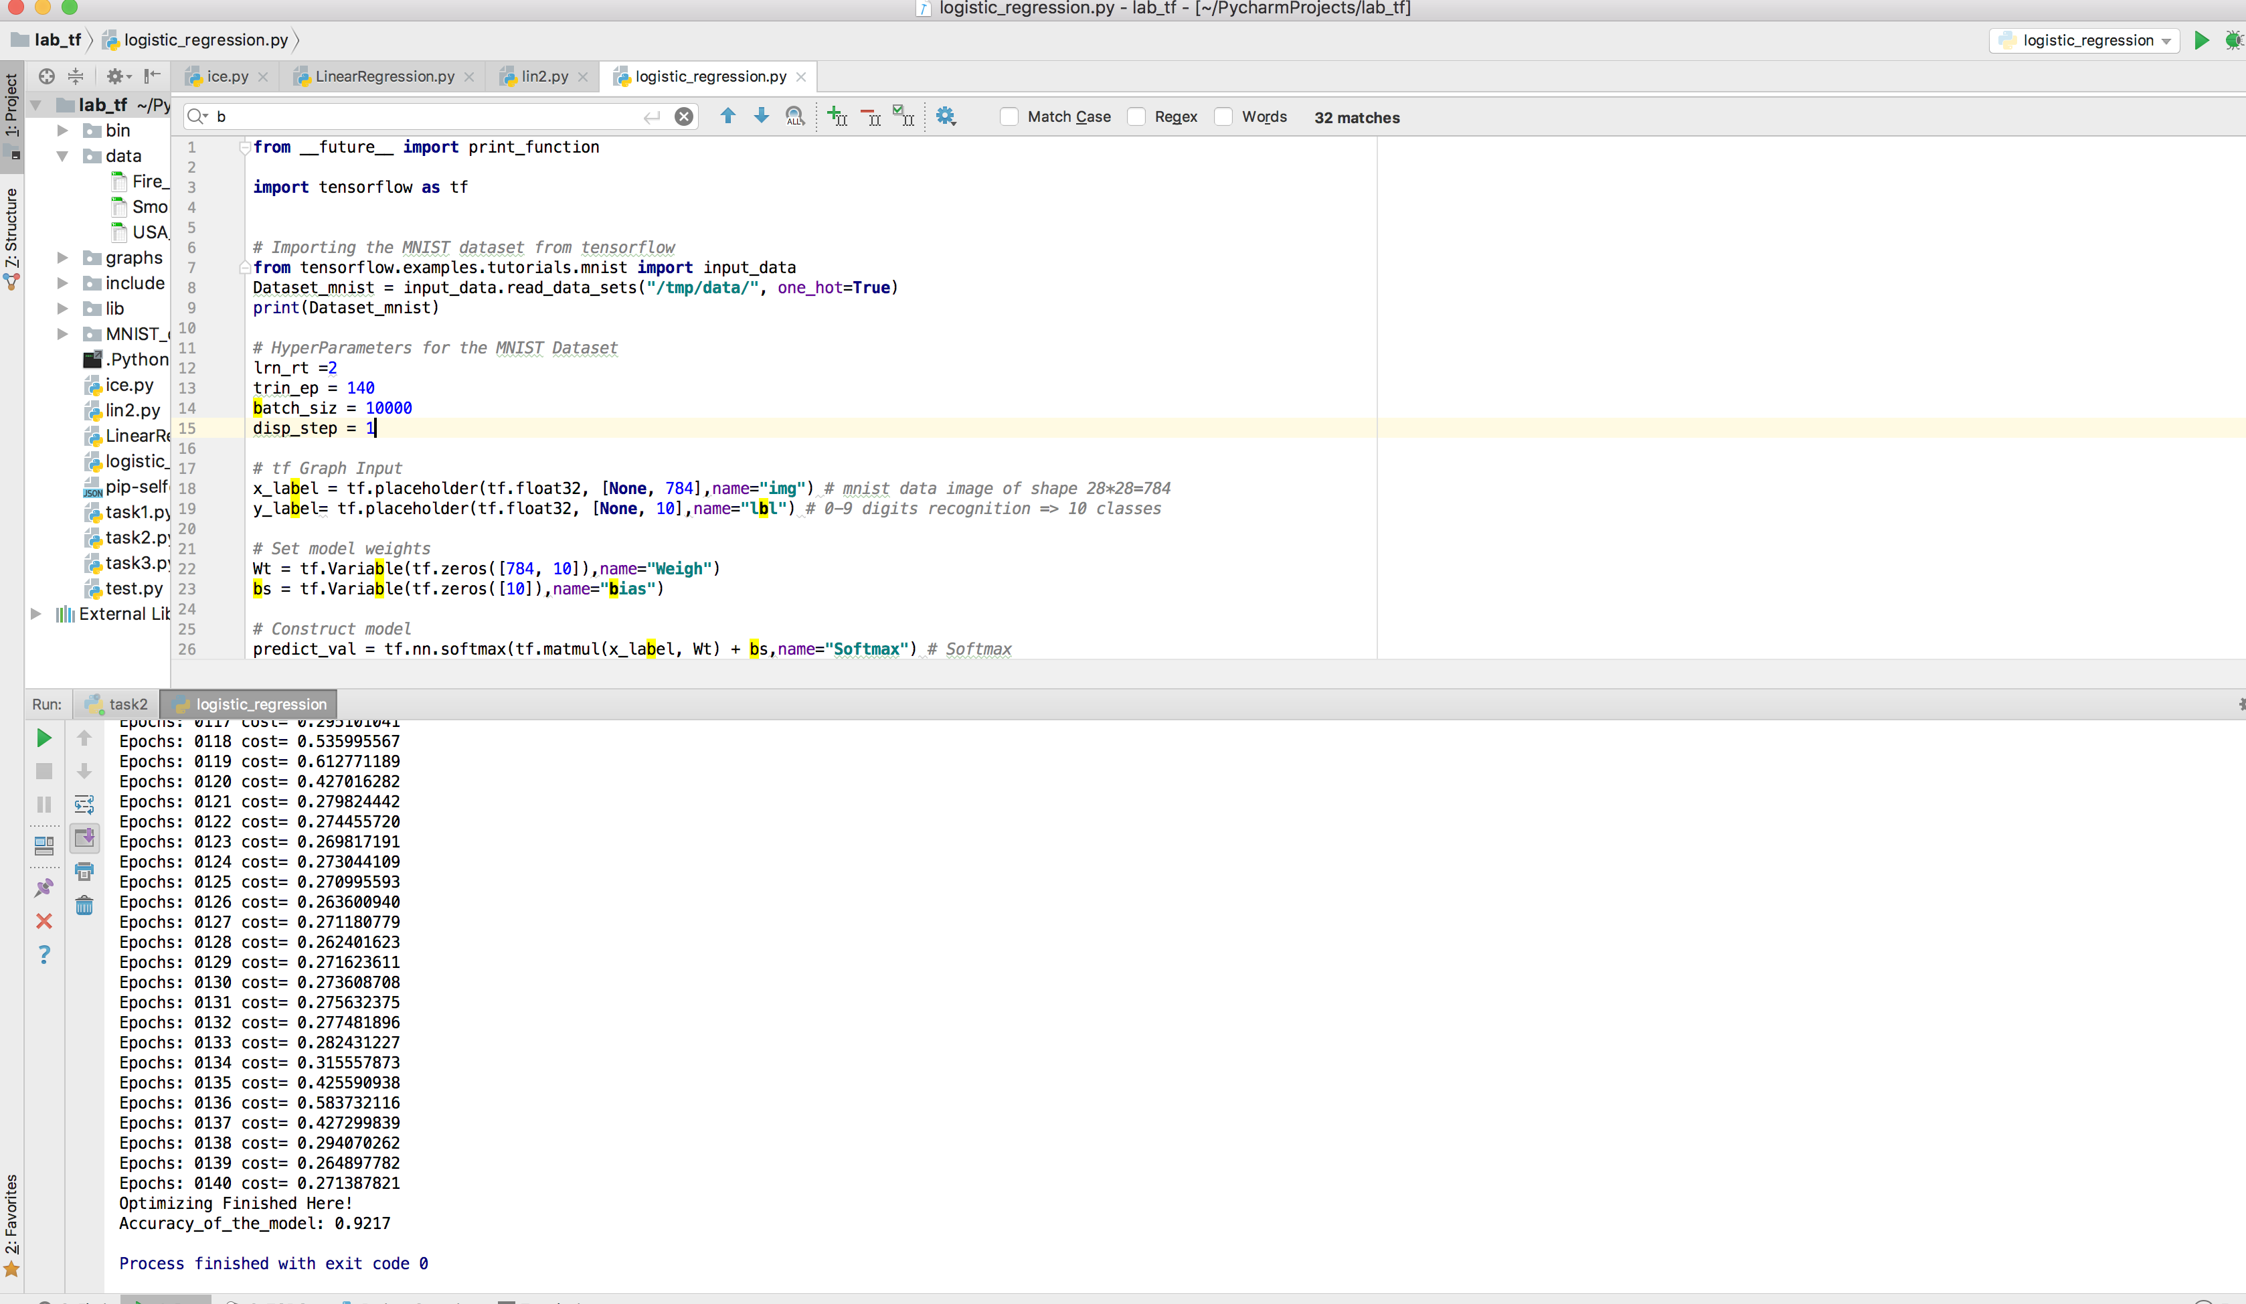

Learning-Rate=0.2

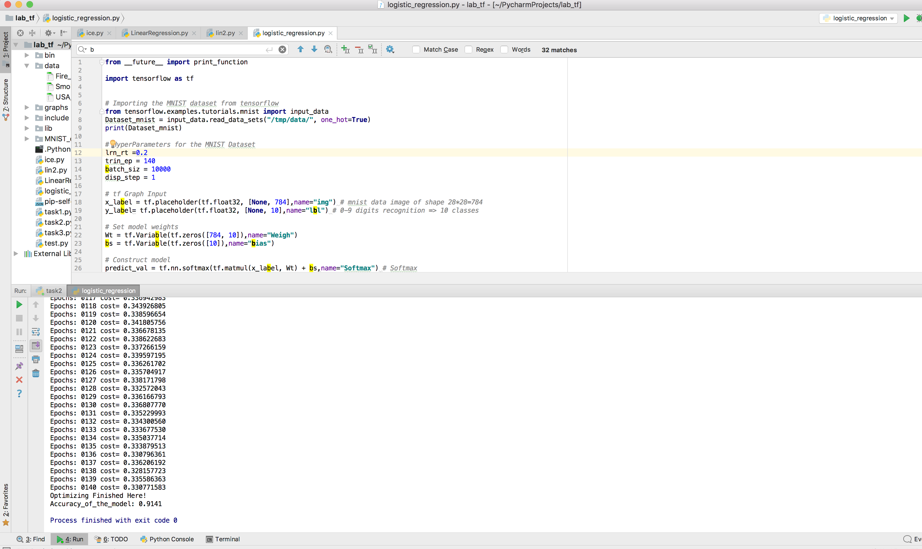

Learning-Rate=0.02

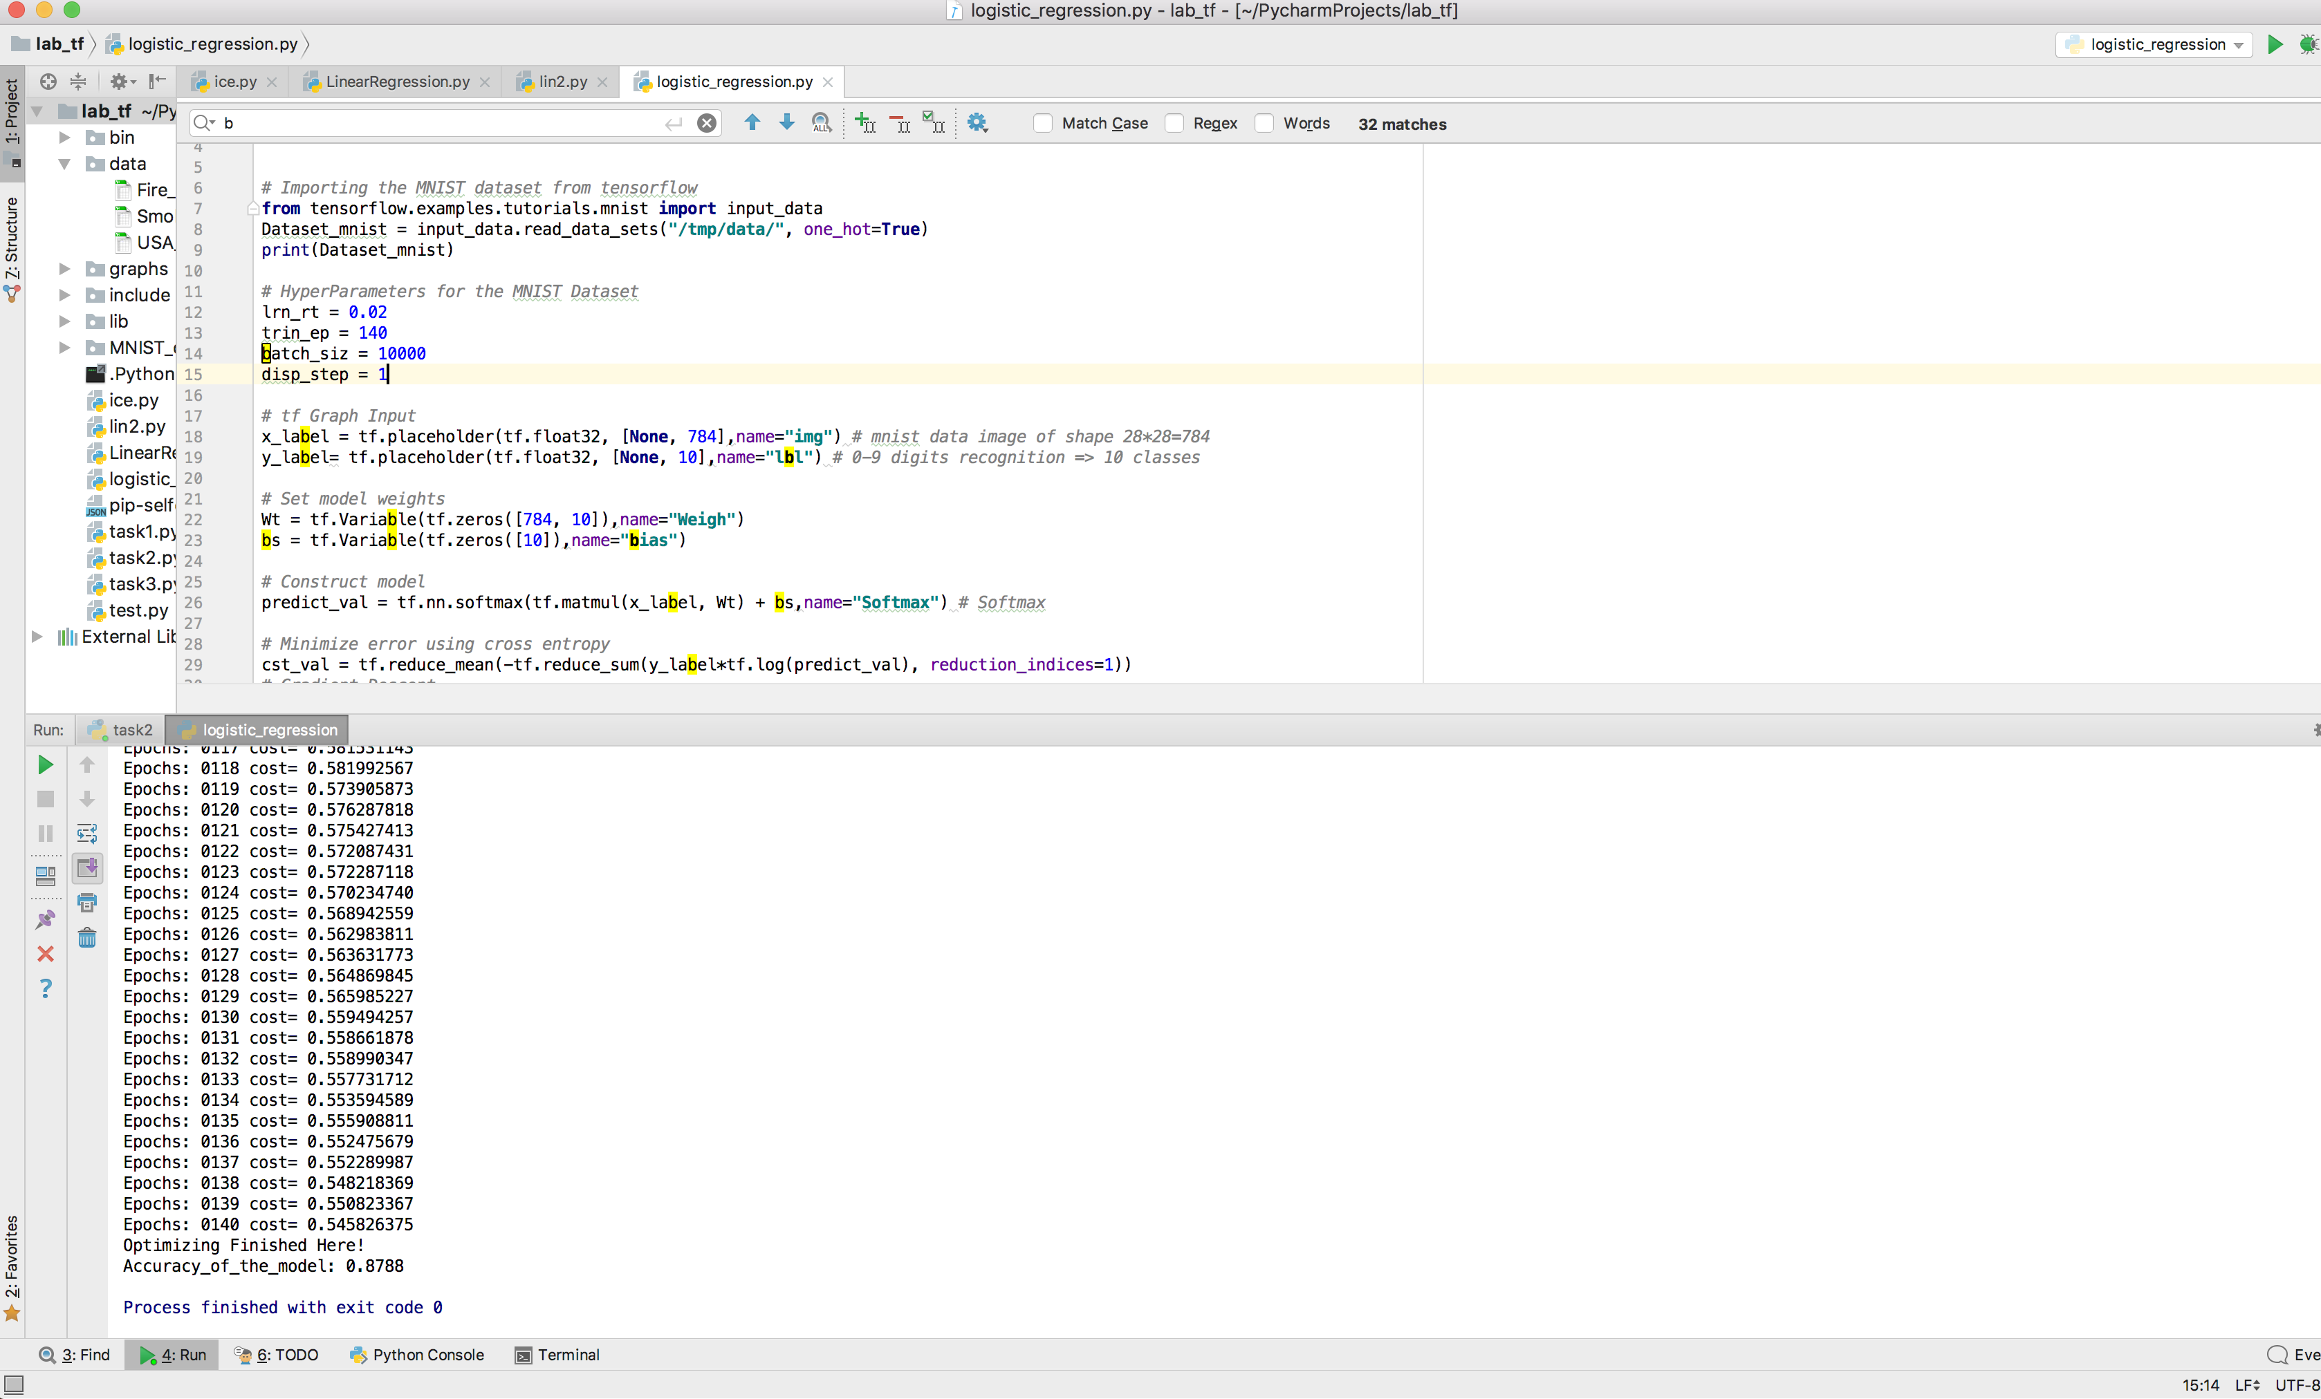

Case 2:

Varying Batch Size:

Training-Epochs=40

Batch-Size=20000

Display-Size=1

Learning-Rate=0.1

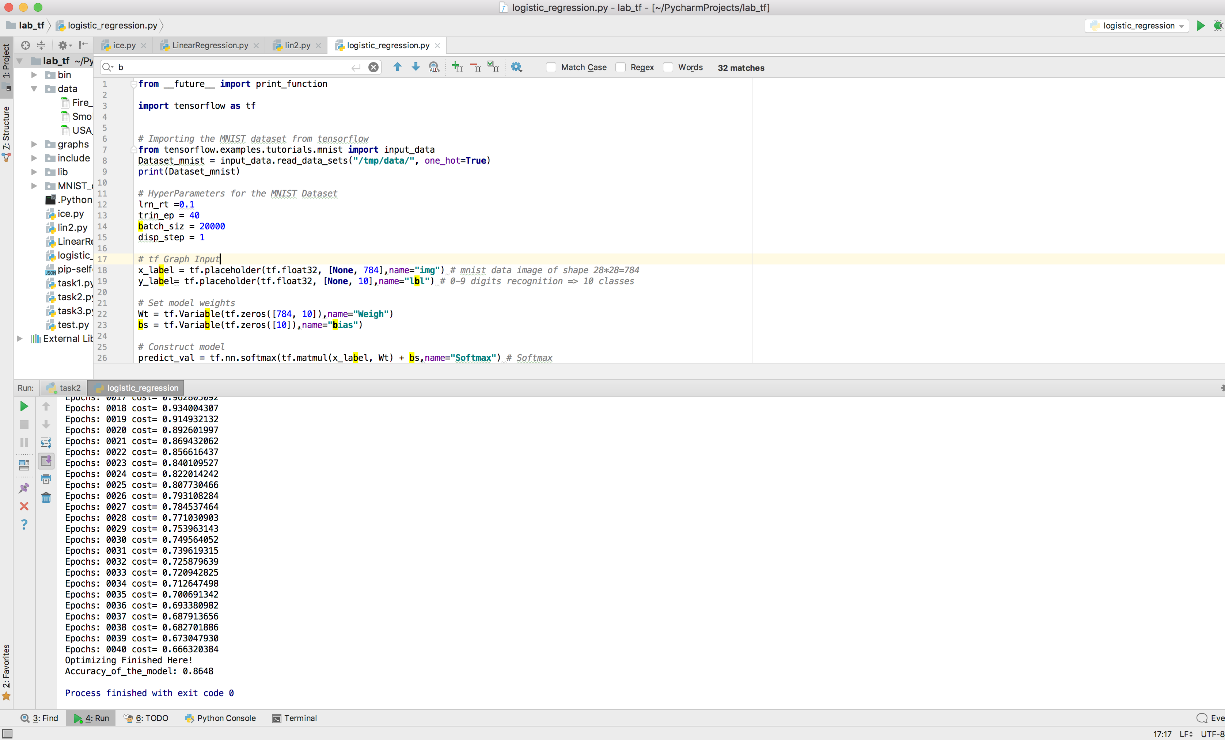

Batch-Size=1000

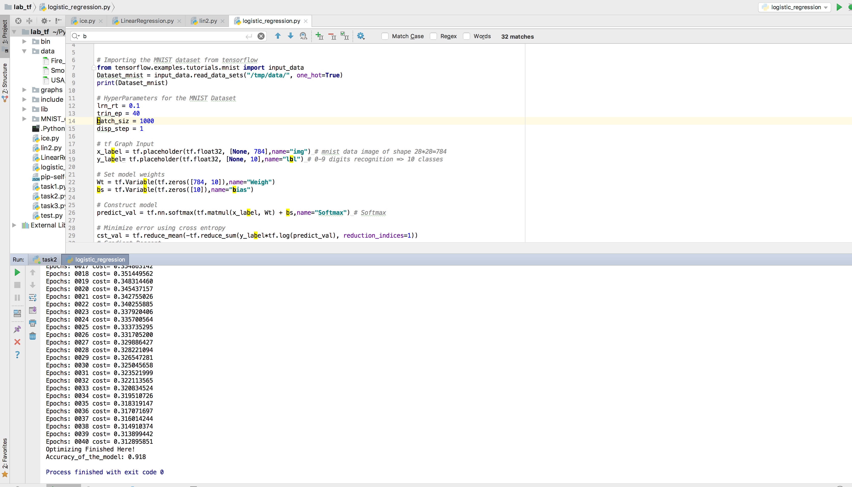

Batch-Size=100

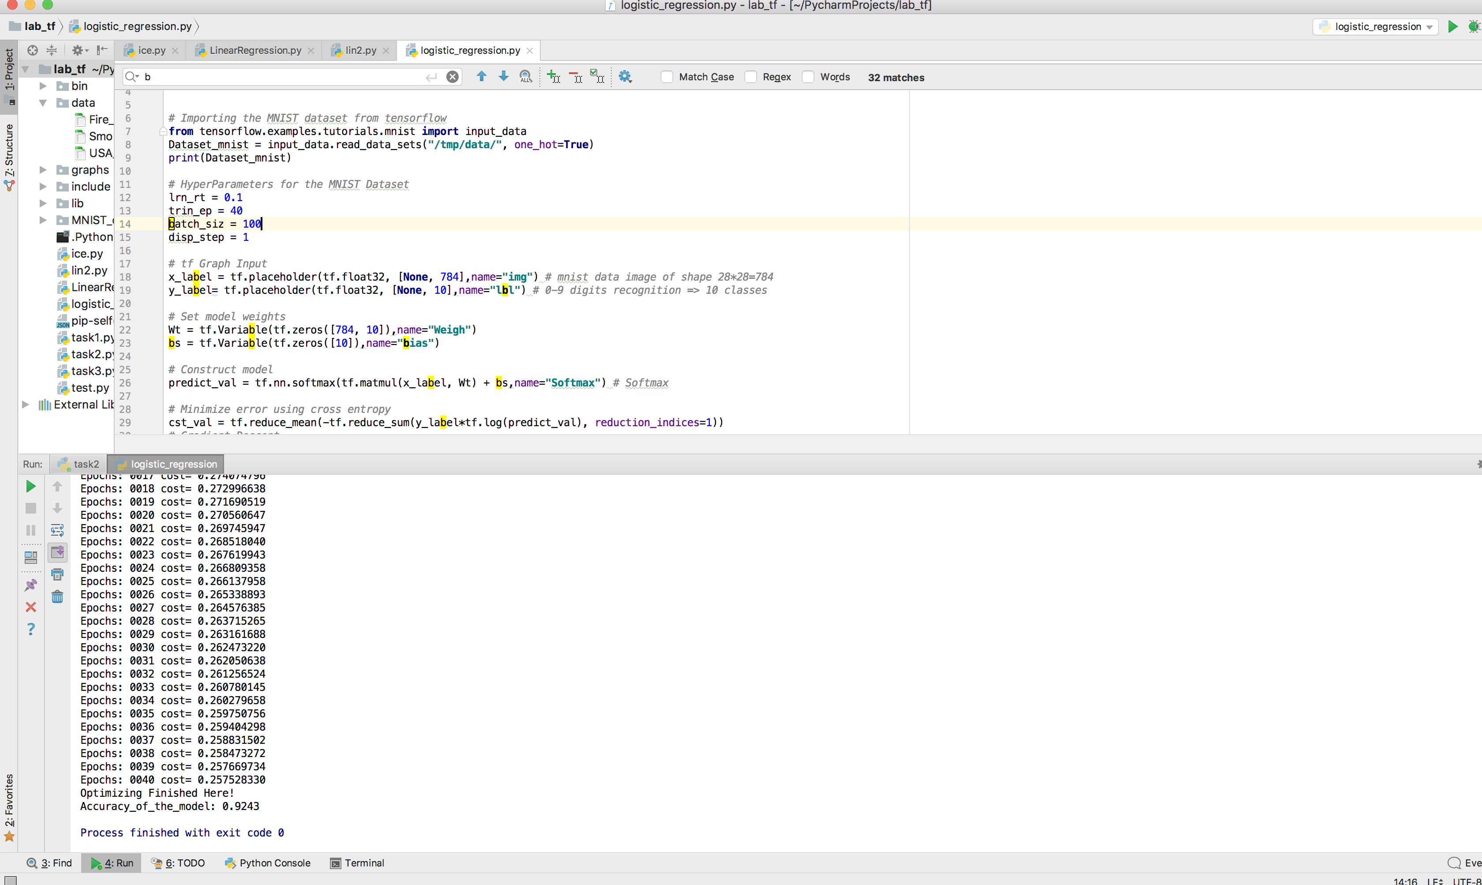

Case 3:

Varying Epoch Size:

Training-Epochs=40

Batch-Size=1000

Display-Size=1

Learning-Rate=0.1

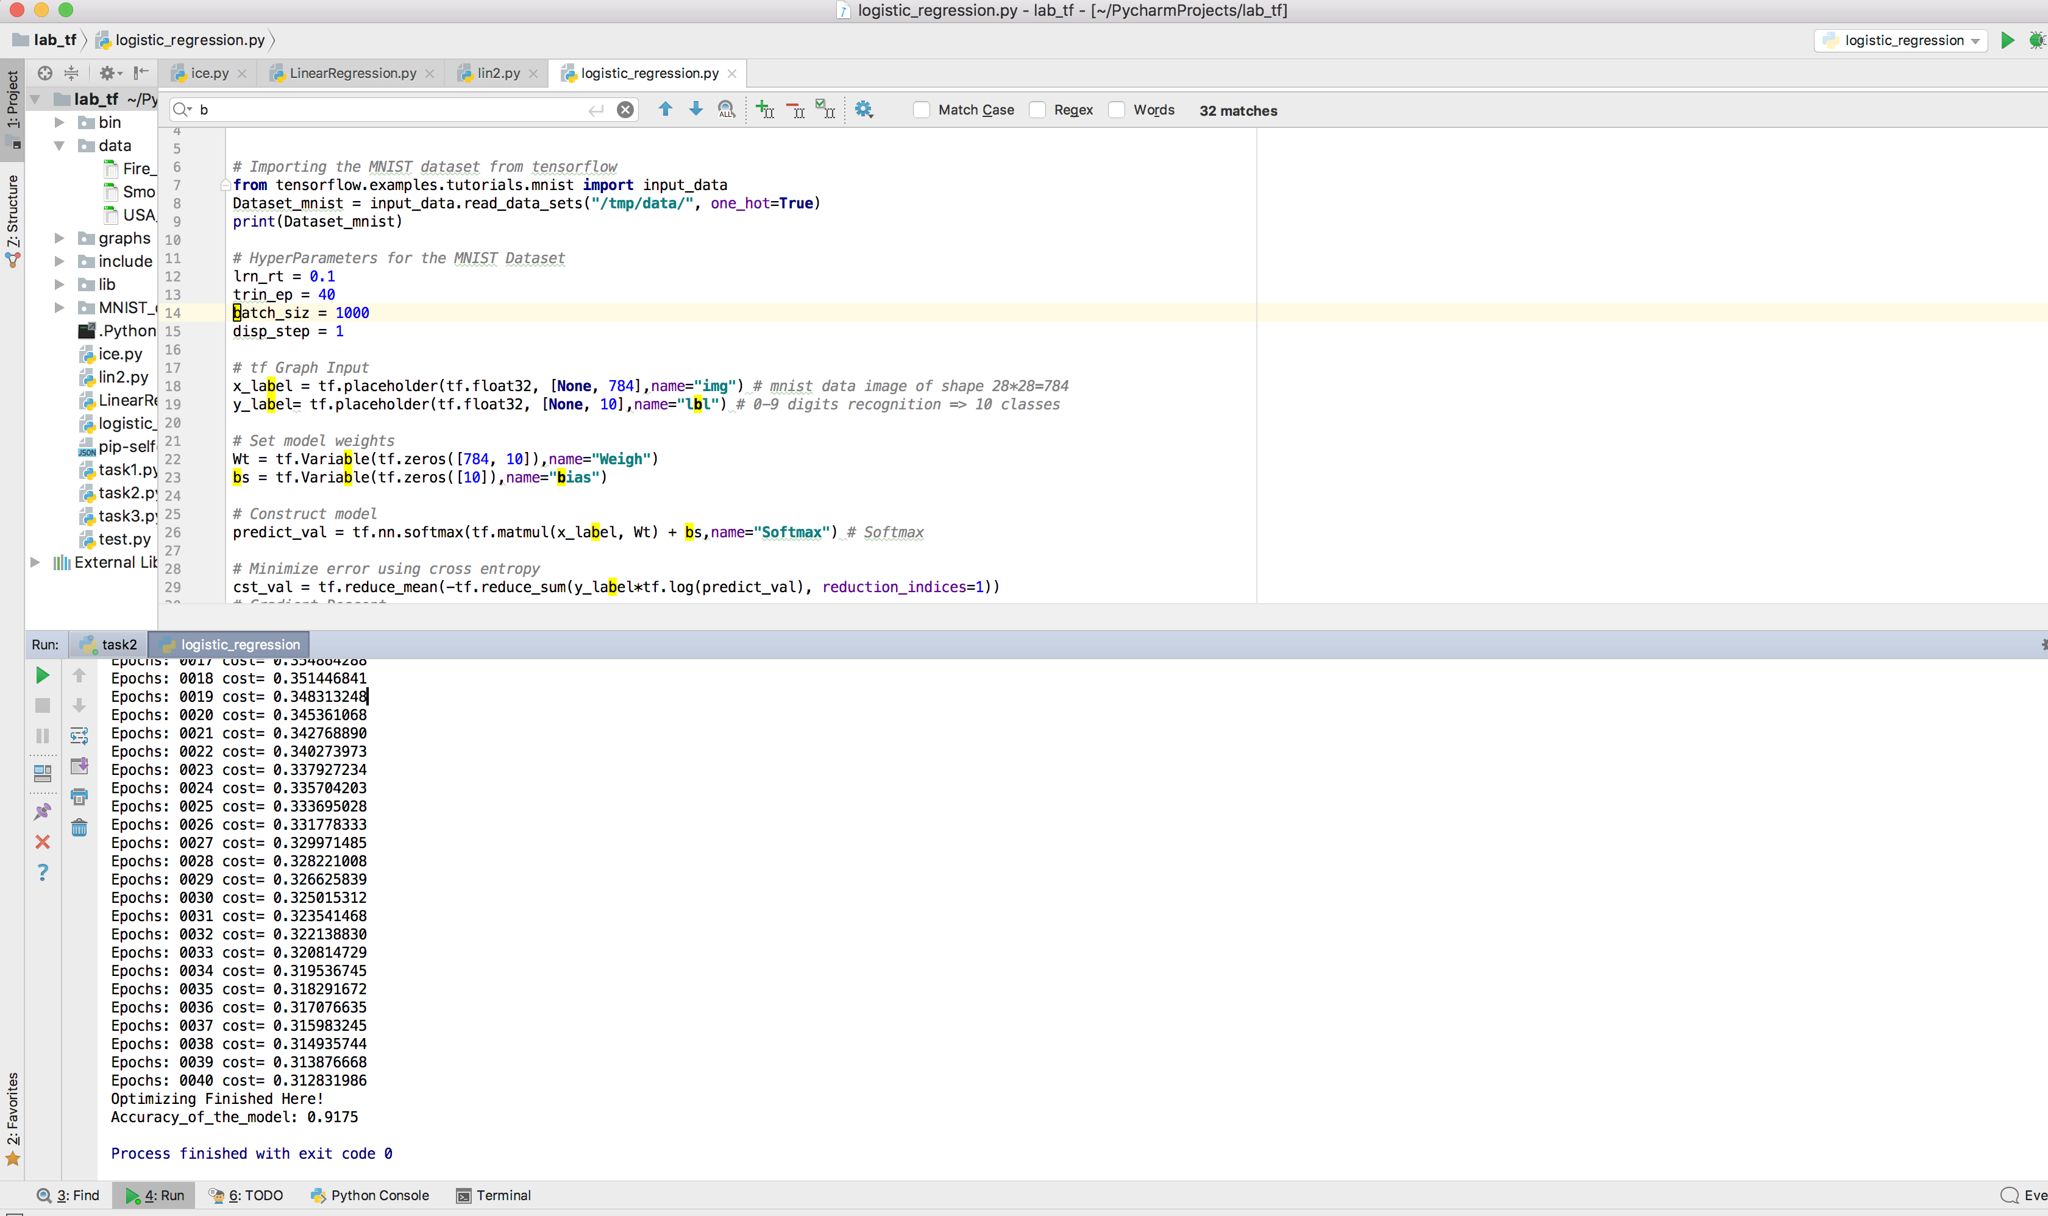

Training Epochs:100

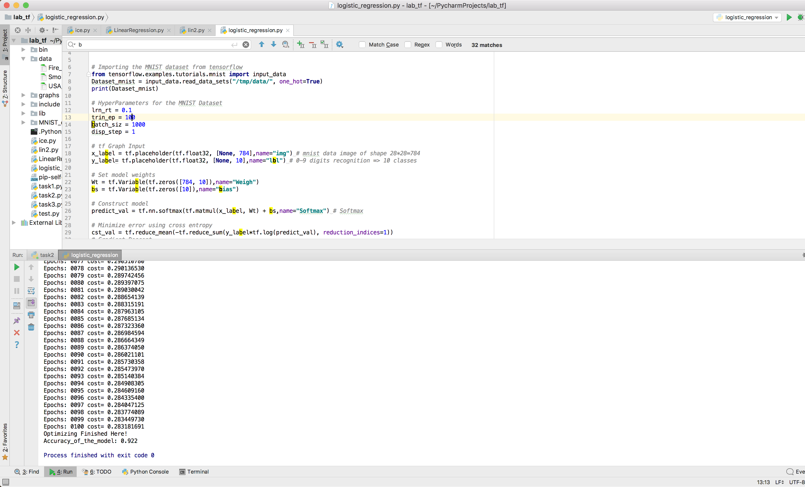

Training Epochs:200

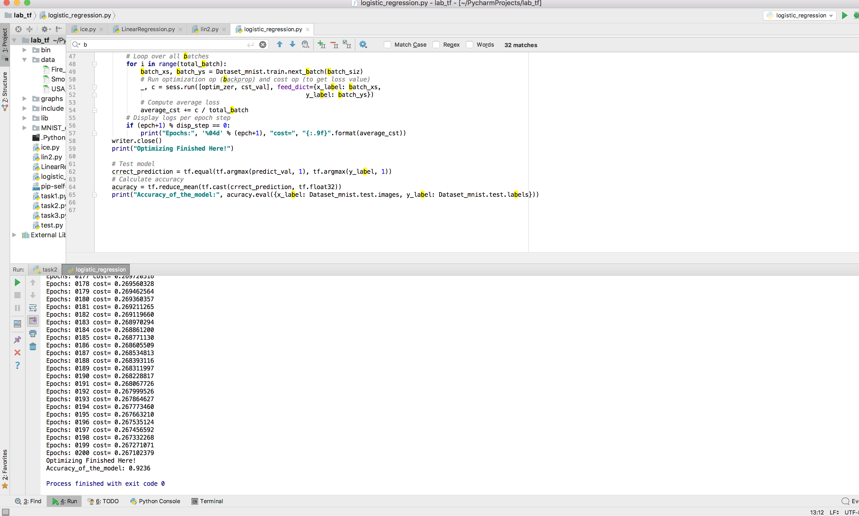

**Conclusion:**

Logistic Regression by using MNIST Dataset can have an Accuracy of 92%. The accuracy is varied by changing the Hyper-parameters as you seen above.

* As learning rate increases in the hyper-parameters with constant value for the Training Epochs, BatchSize and DisplaySize the Accuracy Increases.
* As BatchSize increases in the hyper-parameters with constant value for the Training Epochs, Learning Rate and DisplaySize the Accuracy Decreases.
* As Training Epochs increases in the hyper-parameters with constant value for the Training Epochs,BatchSize and DisplaySize the Accuracy Increases.

**References:**

1. [**https://www.oreilly.com/learning/not-another-mnist-tutorial-with-tensorflow**](https://www.oreilly.com/learning/not-another-mnist-tutorial-with-tensorflow)
2. [**https://www.tensorflow.org/versions/r1.3/get_started/mnist/beginners**](https://www.tensorflow.org/versions/r1.3/get_started/mnist/beginners)
3. [**https://web.stanford.edu/class/cs20si/2017/lectures/notes_03.pdf**](https://web.stanford.edu/class/cs20si/2017/lectures/notes_03.pdf)